Merging VTrees Data Sets

There are times when you might want to combine datasets. VTrees has a tool that can perform simple merges but you will have to perform more complicated merges manually.

Your tree plot table must contain unique plot/subplot records. If there are any records common to both projects, the merge will not be performed. The data will be tested prior to the merge and you will be informed if there is a problem.
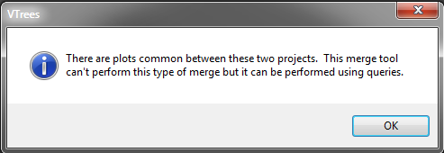

Otherwise, you will get a task completed message.
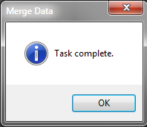
Note that depending on the project size, the merge can take some time but should be less than a minute.

